cd smart

     npm i

     add .env file with seed phrase

     npx hardhat node

     >new terminal

     cd smart

cd ../dapp

npm i

npm run start

Betting Page

Max bet size

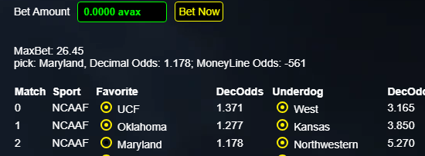

Redeeming

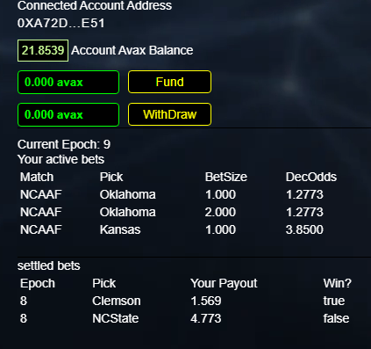

Redeem after settlement

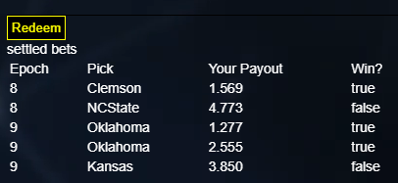

Oracle Page

Contract State

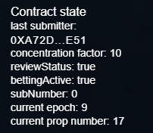

Connected Account State

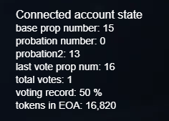

LP Page

Shares

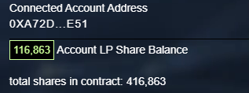

LP totals

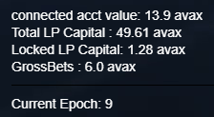

LP exposure

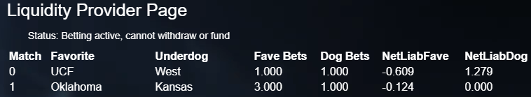

## Betting Restrictions

### Min bet size 1 avax

While testing with trace amounts can be fun, there are DDOS-type of risks generated by allowing trace-amount transactions.

### No betting after game start time

Obviously, a match with fixed odds is easier to bet on when it is partially completed. The ambiguity of blocktime is insignificant to this requirement, as a mere couple of seconds would not expose the contract to risk

### bets constrained by bookie capital

* + ex ante limit of LPcapital/x per match, where x is a number chosen by the oracle. For example, if x=10 and total capital was 100, then the LPs would have at most 10 avax at risk to any one particular event.
  + If 10 units were available, and the concentration parameter was set to 5, then five matches could have 2 units of exposure to the LPs, and use up all of the LP capital. A further bet of 1 unit would not be possible because there would be no more free LP capital left.

## **LP Restrictions**

### LPs are charged a 1% fee if they withdraw in the same epoch

Suppose LPs could deposit and withdraw quickly without a fee. In that case, some LPs might find it profitable to scare away other LPs by depositing large amounts to discourage other LPs, who would see low expected returns given a large capital base. Once scared away, the malicious LP would withdraw capital to make the return attractive. This tactic would not help the LP collective, so they are explicitly discouraged via this fee.

### LPs cannot withdraw in the same epoch they claim token rewards

This prevents LPs from claiming rewards multiple times. There is a fixed amount of token rewards in the betting contract.

### LPs cannot fund or withdraw when betting is active

This prevents LPs from avoiding or taking advantage of information about bet outcomes as they accrue.

### LP capital exposure is limited on any one match.

If the LPs have 100 ETH, an adjustable concentration factor prevents the LPs from having an exposure greater than 100/concFactor in any event.[1] This helps control diversification risk. The concentration factor is constrained to be between 2 and 16, as the optimal number will be determined by experience.

## Odds Restrictions

### One odds number in the contract

Standard odds are presented as a pair, with a spread so that simultaneous bets on both teams lose money for the bettor and make money for the house. A prominent attack surface for a smart contract would be for the odds to imply an arbitrage, as the offsetting bets would generate a sure profit, enabling the hacker to drain virtually all the LP's capital at settlement. By using a single number, that attack is eliminated. The 4.5% vig creates a competitive two-sided offer, a standard requirement for market makers on centralized exchanges.

The odds for the opponent are calculated via an algorithm. By restricting the odds to apply to the favorite, we can restrict the range of allowable odds, as no favorite has decimal odds greater than 2.000. This makes it easier to exclude bogus odds.

### No extreme odds

Matches with extreme underdogs (e.g., 10-1) are attractive for hackers, as they generate the most revenue for the smallest amount of capital. Initial decimal odds on favorites greater than 7:1 are not accepted. Such matches will not be covered. This would eliminate about 5% of NFL games historically but is common among college football and MMA. This also eliminates bets like "who will win the next golfing event" because these improbable bets require too much LP collateral.

The front-end is helpful, but not necessary. One can use Remix, python, or any other method of transacting with the contract, which is permissionless.

## Odds Translation

To convert moneyline odds into Decimal odds, we have the following.

For positive moneyline odds: (Moneyline odds/100) + 1 = Decimal odds

For negative moneyline odds: (100/Moneyline odds) + 1 = Decimal odds

To translate decimal odds into moneyline odds that are prominent on NFL betting sites, we have the following adjustment mechanism:

If decimal odds are greater than 2.0: 100 × (decimal odds – 1) = Moneyline odds

If decimal odds are less than 2.0: -100/(decimal odds -1) = Moneyline odds

To translate moneyline odds to fractional odds:

For positive moneyline odds: Moneyline odds/100 = Fractional odds

For negative moneyline odds: -100/Moneyline odds = Fractional odds

To convert decimal odds into winning probability.

prob(win) = 1 / Decimal odds

Decimal odds = 1 / prob(win)

The most common odds offered for the NFL are presented in moneyline form as ‑110 for both teams, which would be 1.909 in decimal odds or 10/11 in fractional odds. A flat book on such a wager would receive 220 and payout 210. In this way, the 'house' makes money used to pay for various costs and a profit from the house. The implicit profit ('vig') in this case would be 4.55%, 10/220. The general formula for estimating the vig is given by the following formula, where *p* and *q* are decimal payouts (e.g., 1.909 for a standard even money bet) for opposing teams.



The spreadsheet 'ASB.xlsx' presents a page where people can see how these transformations are applied. Those interested in sending odds to the contract will find it a helpful template.

## Odds in the contract

The odds format is based on two primitives. First, the reciprocal of decimal odds is the fair probability of winning that would make the bet have zero expected value.



The second is that the sum probability of betting on both teams equals "1 + vig', or 1.048.



Thus, for an even bet, the odds for both teams would be 52.4%, as 0.524+0.524=1.048. Both teams cannot have 52.4% win probabilities, so the 2.4% premium reflects the vig and tells one how much of an edge one needs to beat the house.

We need the LPs and oracle to split the vig. This is done by setting the vig at 2.25% in terms of the odds the LPs experienced in the betting contract. This implies the even bet probability of winning is 51.2%. The contract applies this logic at the time of the bet with the following logic

    if (_team0or1 == 0) {

      betPayoff = ((1e7 / (512 + probSpreadDivBy2) - 1e4) * _betAmt) / 1e4;

    } else {

      betPayoff = ((1e7 / (512 - probSpreadDivBy2) - 1e4) * _betAmt) / 1e4;

    }

Here, the constants 1e7 and 1e4, as well as the number 512 instead of 0.512, accommodate the absence of floating point arithmetic in Solidity.

When a bettor wins, his payout is then taxed at 5%. As payouts on average are 50% of the total amount bet on both teams, one-half of 5% is 2.5%, which is the total vig in the contract, 4.8%. This is applied at redemption via the code:

      if (outcomeMap[epochMatch] != lose) {

        payout += betContracts[_subkId].betAmount;

        if (outcomeMap[epochMatch] == win) {

          payout += (betContracts[_subkId].payoff * 95) / 100;

        }

      }

And is applied at settlement to create the oracle dividend via

         uint256 oracleDiv = ORACLE_5PERC * uint256(winningsPot);

Here ORACLE_5PERC adjusts the winning payoffs by multiplying it by 0.05. It is 5e12 merely because we are adjusting decimals (i.e., 1 ETH is 1e4 in the contract but 1e18 on the blockchain. So, 5e12 × 1e4 = 5e16, 5% of 1 ETH.

By sending a single number representing the difference in win probability between the favorite and underdog, we get a number from zero to one. ASB adds this probability spread, divided by two, to the base 51.2% probability for the favorite and subtracts the same 'probability spread divided by two' from the win probability of the underdog. One then takes the reciprocal to get the decimal odds for the favorite and underdog.

The ASB repo contains an MS Access database that takes raw decimal odds data and transforms it into the probability difference divided by two. When pasted into its Excel spreadsheet, it generates the data in the correct format for sending via a Python program. The basic algorithm is this:

1. Take an initial set of odds
   * Home team: +135 moneyline, 2.350 decimal
   * Away team: -150 moneyline, 1.667 decimal
2. rearrange so that the favorite team is first
   1. team[0]: 1.667, team[1]: 2.350
3. Translate into win probability
   1. Prob(win) = 1/decimalOdds
   2. team[0]: 60.00%, team[1]: 42.55%
4. calculate probability spread/2
   1. spread = 0.60 – 0.4255 = 0.1745
   2. spread/2 = 0.0872
5. Calculate new favorite, team[0], prob(win)
   1. prob(team[0] win) = 51.2% + 8.72% = 59.92%
   2. prob(team[1] win) = 51.2% - 8.72% = 42.48%
6. Translate prob(team[0] win) into decimal odds.
   1. Gross decimal Odds(team[0]) = 1 / 0.5993 = 1.669
   2. Gross decimal Odds(team[0]) = 1 / 0.4248 = 2.354
7. Adjust for the 5% oracle fee applied to winnings
   1. Net decimal Odds(team[0]) = 1+0.669*0.95=1.635
   2. Net decimal Odds(team[1]) = 1+1.354*0.95=2.287

In this example, the vig is 4.66%: 1 - 1.635 * 2.287 / (2.287 + 1.635). The above algorithm generates a vig near 4.5% across the range of odds covered in this contract. The tricky part of the above algorithm is that the raw odds spread, in the probability of a win, is added to 51.1%. If there were no oracle payment, this number would be 52.5%.

The website AVAXsportsbook.com displays the decimal odds users receive—net odds—if they win, though the odds are stored as the win probability spread divided by two times 1000.

The website avaxsportsbook.com displays the decimal odds users receive if they win. For example, a user seeing odds of 1.900 will receive back 1.900 times their bet amount.

## Redeeming a Bet

Bets are stored in a mapping within a better’s struct, and after 16 bets, no further bets can be made until they are redeemed. Redemptions can only occur when a bettor has no active bets, so a bettor should redeem his bets after settlement if he anticipates a problem. All bets in the array are settled for the bettor. Each bet is represented by the unique combination of epoch, match, and pick. At settlement, a bets hash refers to a struct containing this information, and a mapping generated at settlement allows redemption. Users to redeem bets by clicking a single button (it is one transaction).

## LP Accounting

LPs own a pro-rata portion of the contract's revenue based on their percentage of LP capital before that week's events. Statistically, the LP capital will grow each settlement due to the vig; this is how LPs make money. As the relevant LP credit/debit occurs at settlement, the LP's AVAX/share value is fixed each week when users can withdraw or invest.

An initial investment generates the following shares:

LPshares = AVAX invested × TotalLpShares / TotalLpAvax

For example, assume the contract has 123 AVAX owned by its LPs, who have 100 shares. This AVAX may be free or locked up as collateral for upcoming contests. This implies each LP share is worth 1.23 AVAX.

LP AVAX LP TotalShares AVAX/Share

123 100 1.23

Suppose Alice wishes to invest 10 AVAX into this pool. The above formula implies she would receive 8.13 shares (10/1.23). This would change the pool's balance sheet to

LP AVAX LP TotalShares AVAX/Share

133 108.13 1.23

Note the ratio of AVAX/share is the same after Alice's investment, so existing shareholders do not lose or gain money via Alice's new investment.

If we assume the LP collective gained 2 AVAX that week, the new balance sheet after a settlement will look like this:

LP AVAX LP TotalShares AVAX/Share

135 108.13 1.25

The increase from 133 to 135 reflects a 1.5% profit from that epoch's games. If Alice then sold her shares, she would receive AVAX using a transformation of the above formula:

AVAX Withdrawal = TotalLpAvax × SharesSold / TotalLpShares

Selling 8.13 shares would generate 10.15 AVAX, a 1.5% return on their investment, identical to how much the AVAX LP pool rose over that period.

In this way, any LP investment or withdrawal reflects the percent change in the size of the LP pool's AVAX/share over the investment period.

## Oracle Accounting

Oracle token holders must deposit their tokens in the oracle contract to vote and vote to receive revenue. When a weekly settlement transaction is executed, the oracle's 5% fee is applied to the winnings and sent to the oracle contract. The '*feePool'* state variable reflects the lifetime amount of AVAX per token paid to the oracle contract.



When an oracle token holder deposits into the contract, their account notes the current value of *feePool*. When that oracle token holder withdraws or adds to their account, the token holder is sent their entire accrued AVAX using the formula



Having tokens in the oracle is a necessary but insufficient condition for being paid. The contract then takes the total number of tokens





This account's *OraclePoughback* is sent to the Oracle *feePool* as if it were revenue from a settlement.

There is no scenario where the token holders can lose accrued revenue, either due to a lucky win streak by bettors or an oracle hack. Token holders can be sure the contract is in balance, where accounts payable are always equal to AVAX in the contract.

**How to bet**



only when betting is active (odds have been sent to the contract by the oracle)

only prior to the game start time (sent in schedule using GMT UTC)

constrained by LP capital

click

type in amount of avax on bet

click bet

**How to redeem**



only when there are no active bets

after 16 bets, user must redeem so account can bet again

One can redeem whenever. Funds do not disappear if never claimed.

wait until settlement, which happens early in the week, to remove active bets

click redeem

**How to fund betting accountss**



only when betting is not active

betpage

fund: enter amount and click fund

**How to invest in the house**



only when betting is not active

go to bookie page

fund: enter amount and click fund

**How to deposit tokens in oracle**

approve:

Deposit:

**How to withdraw as bettors**

withdraw

**How to withdraw as bookies**

**s**

sell ‘shares’.

How to claim Rewards



1. This number is arbitrary, and experience will reveal the best parameter. This protects LPs as diversification lowers risk in the standard way--This factor can be adjusted, as experience will generate useful information on the best diversification factor.